Digital Humans & Character Animation
Milestone 2: Space, Transformation & Camera
A Full 3D Transformation Pipeline, Camera/Projection System, and Numerical Stability Analysis
Submitted Report

0. Milestone Overview
Milestone 1 established a skeletal hierarchy, forward kinematics, and Linear Blend Skinning within a single character's own local/world space. Milestone 2 extends that system into full spatial correctness: every vertex now passes through a complete, from-scratch Model → View → Projection → NDC → Screen pipeline driven by an explicit camera model, and the numerical behavior of that pipeline is measured empirically rather than assumed.
Requirement | Where it is satisfied
3D transformation pipeline | Section 1 — Model/World → View → Projection → NDC → Screen, all derived and implemented from scratch in camera.py
Camera model (view + projection) | Section 1.1–1.2 — look-at view matrix, perspective and orthographic projection matrices
System/hardware constraint awareness | Section 3 — depth-buffer precision, float32 (GPU) vs float64, near/far ratio trade-offs
Fully spatial 3D system | Section 2 — rendered perspective, orthographic, three-view, and camera-orbit (turntable) outputs
Transformation pipeline implementation | camera.py (attached), reusing the Milestone 1 Skeleton/SkinnedMesh unchanged
Numerical stability analysis | Section 3 — four empirical experiments with quantitative results

1. The 3D Transformation Pipeline
The Milestone 1 skeleton already produces per-joint world transforms via Forward Kinematics, and per-vertex world-space positions via LBS. Milestone 2 does not change either of those — it adds the remaining stages a real renderer needs to turn those world-space points into an image:
Model space --(world transform, Milestone 1 FK + LBS)--> World space
World space --(view matrix)-------------------------> Camera (eye) space
Camera space --(projection matrix)--------------------> Clip space
Clip space --(perspective divide, x,y,z / w)---------> Normalized Device Coordinates (NDC)
NDC --(viewport transform)--------------------> Screen / pixel space
This is precisely the fixed pipeline every real-time renderer (OpenGL, DirectX, a game-engine vertex shader) implements; Section 1.1–1.3 derives each new matrix, and Section 2 shows it running end-to-end on the Milestone 1 character with no rendering library performing the 3D math on our behalf — rasterization is plain 2D line drawing once our own pipeline has produced screen coordinates.

1.1 View Matrix (World → Camera Space)
Given an eye position, a look-at target, and a world “up” hint, an orthonormal camera basis is built directly:
forward f = normalize(target − eye) (camera looks down −f)
right s = normalize(f × world_up)
up u = s × f (re-orthogonalized against f)
The view matrix is the inverse of the camera's world transform (rotation columns s, u, −f, plus the eye translation). Because that world transform is a pure rotation-plus-translation (a rigid transform), its inverse has a cheap closed form: the inverse of an orthonormal rotation is simply its transpose, and the inverse of a translation is its negation. This avoids a general 4×4 matrix inverse entirely — both faster and numerically safer, since general inversion can amplify error when a matrix is close to singular, while a rigid transform's inverse never has that risk.

1.2 Projection Matrices (Camera → Clip Space)
Two projections are implemented for direct comparison:
Projection | Behavior
Perspective | f = cot(fovy/2) scales x,y by depth via the 1/(−z) relationship packed into w; distant objects shrink, parallel lines converge — how human vision and cameras actually work.
Orthographic | A simple affine remap of a view-aligned box to [−1,1]³; no perspective divide distortion — used for technical/CAD-style views and to isolate whether an artifact is a projection effect or a genuine geometry error.
The perspective matrix's third row is chosen so that camera-space depth −near maps to NDC z = −1 and −far maps to z = +1, while row 4 packs −z_camera into clip.w so the GPU's perspective divide produces the correct nonlinear depth relationship analyzed quantitatively in Section 3.3.

1.3 Perspective Divide, Viewport, and the One Genuinely Nonlinear Step
Clip-space coordinates are converted to NDC by dividing x, y, and z by the clip-space w: (x,y,z)/w. This is the only nonlinear step in the entire pipeline (every other stage is a linear matrix multiply), and it is also the pipeline's one numerical hazard — as w approaches zero (a point near the camera's eye plane), the divide can blow up to ±∞ or produce NaN. Two safeguards are implemented:
- A defensive epsilon clamp (project_point / project_points in camera.py) so a single degenerate vertex cannot NaN an entire frame.
- Proper near-plane clipping (clip_segment_to_near_plane): a segment crossing the near plane is intersected at w = near and only the in-front portion is kept — this is the correct, production approach (the epsilon clamp is a safety net, not a substitute for it).
NDC coordinates are then mapped to pixel space by the viewport transform: x → [0,width], y → [0,height] with y flipped, since image row 0 is conventionally the top of the screen while NDC y=+1 is conventionally “up.”

2. Fully Spatial 3D System — Rendered Output
All figures below reuse the identical Milestone 1 skeleton and skinned mesh; only the camera changes. Every image is produced by projecting world-space points through camera.py and drawing plain 2D line segments at the resulting pixel coordinates — there is no 3D plotting library involved in how depth or perspective is computed.

2.1 Perspective vs. Orthographic
The same character, same camera position, rendered once with each projection — isolating exactly what the perspective divide contributes (convergence of the arms/legs toward the vanishing point) versus a pure parallel projection.
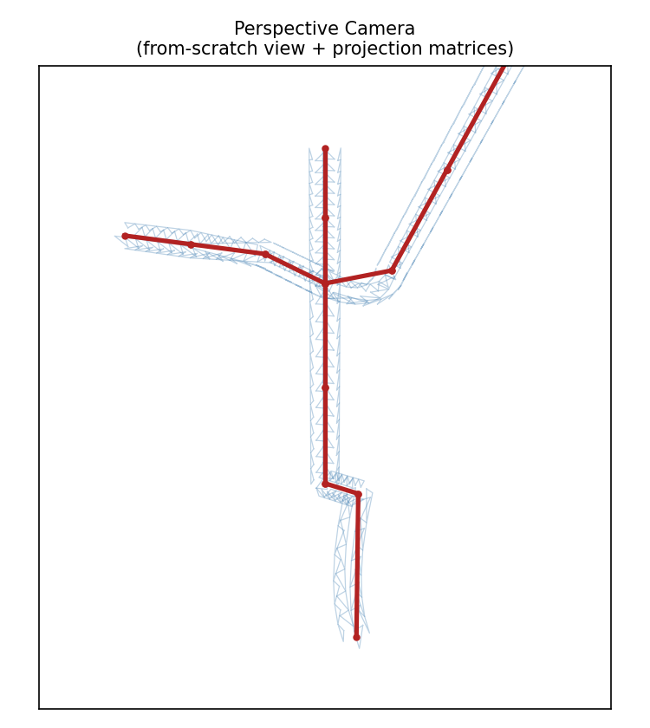
Figure 1. Perspective projection: from-scratch view + projection matrices.
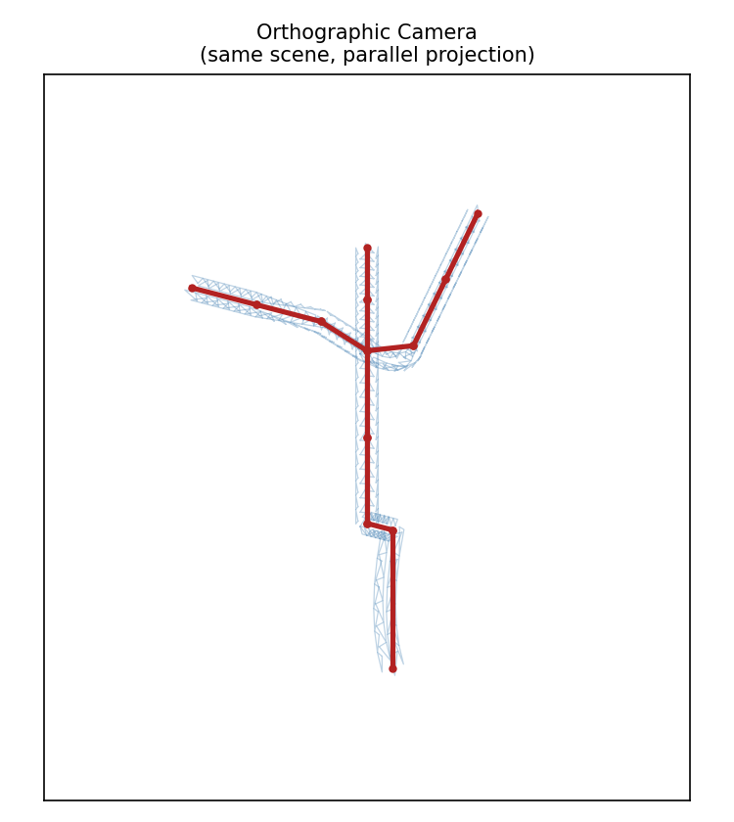
Figure 2. Same scene and camera position, orthographic projection.

2.2 Three Canonical Views, One Code Path
Front, three-quarter, and top-down views generated by only changing the Camera object's eye/target/up — identical projection code, confirming the pipeline is correct for arbitrary camera placement rather than one hand-tuned viewpoint.
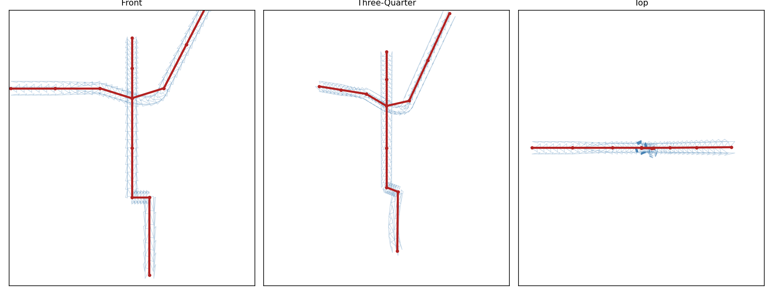
Figure 3. Front / three-quarter / top views through the same MVP pipeline.

2.3 Turntable: Orbiting the Camera Around a Fixed Character
Milestone 1's animation moved joints in object space while the viewpoint stayed fixed. The real test of a camera system is the reverse: keep the character's pose fixed and move the observer. Here the camera orbits the character over 36 frames while eye, target, and up are recomputed from scratch every frame via look_at — the character silently stays rigid and correctly proportioned from every angle, which is the actual definition of “fully spatial correctness.”
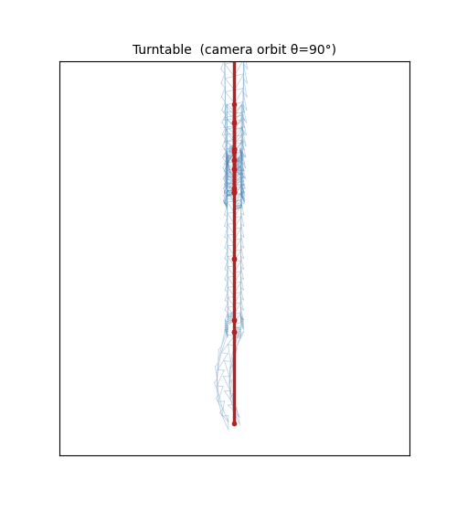
Figure 4a. Turntable, frame 10 (camera orbit ≈ 100°).
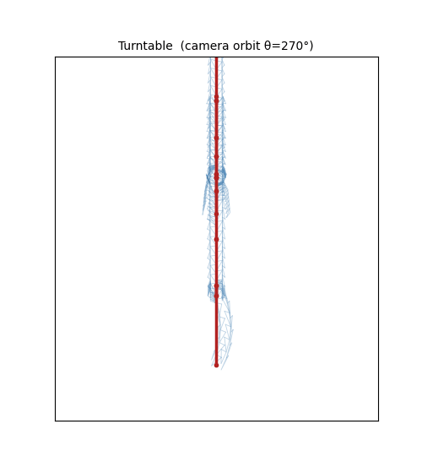
Figure 4b. Turntable, frame 28 (camera orbit ≈ 280°). Full sequence supplied as m2_turntable.gif.

3. Numerical Stability Analysis
Four experiments were run against the actual pipeline code (not a toy model) to find where floating-point error and hardware precision limits genuinely appear, and how much they matter at this system's scale. Full numeric results are in numerical_stability_results.json.

3.1 Quaternion Norm Drift Under Repeated Composition
A small rotation quaternion was composed with itself 5,000 times with no renormalization, in both float32 and float64.
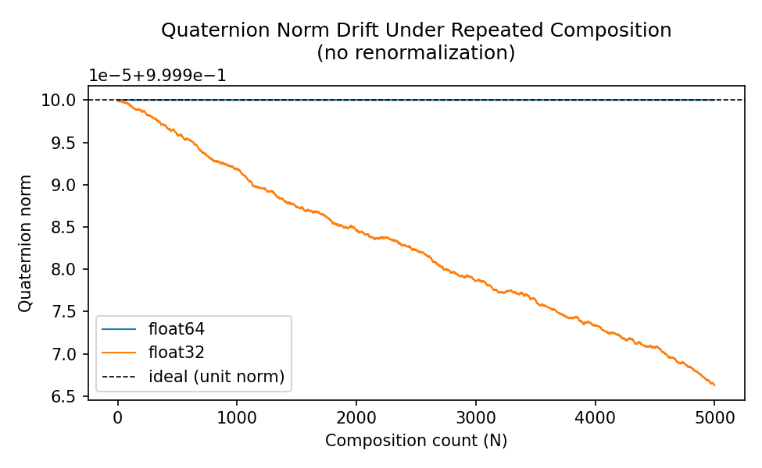
Figure 5. Unit-norm drift over 5,000 compositions, float64 vs float32.
Precision | Final norm | Drift from 1.0
float64 | 0.999999999999738 | ≈ 2.6 × 10⁻¹³
float32 | 0.999966263771057 | ≈ 3.4 × 10⁻⁵
float64 drift is negligible; float32 drift is roughly ten orders of magnitude larger and grows in a random-walk-like manner with composition count. This is exactly why production animation systems renormalize every joint quaternion once per frame (a single cheap division) — an un-renormalized quaternion silently introduces a non-rigid scaling component into the derived rotation matrix, which would slowly shrink or distort a skinned mesh over a long-running animation if left unchecked.

3.2 Forward-Kinematics Chain: Orthogonality Error vs. Hierarchy Depth
A synthetic 50-joint chain (deeper than any real humanoid rig) accumulates the same small rotation 50 times via FK, in float32, without renormalization. Orthogonality error ‖RᵀR − I‖ and determinant error |det(R) − 1| are measured at every depth.
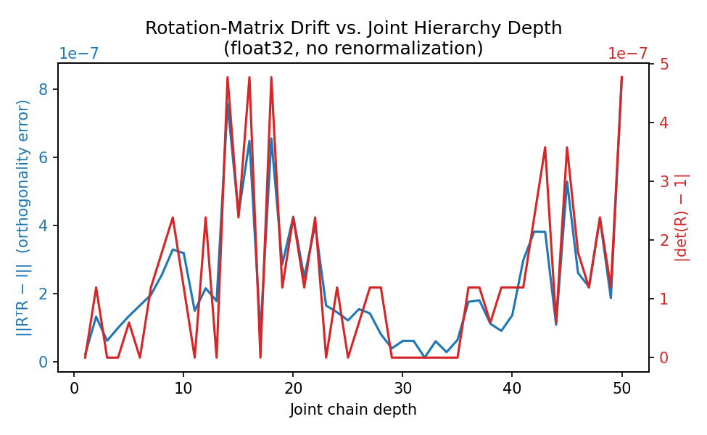
Figure 6. Rotation-matrix drift vs. joint hierarchy depth (float32, no renormalization).
Even at 50 joints deep, both error metrics stay below 10⁻⁶ — real character rigs (20–90 joints) will not accumulate meaningfully visible drift within a single frame's FK pass. The practical conclusion is that per-frame renormalization is cheap insurance rather than a fix for an urgent problem: this codebase's animation loop renormalizes anyway, since the cost is one division per joint per frame and the alternative is an error that, while small per-frame, is unbounded over an arbitrarily long running session.

3.3 Depth-Buffer / NDC Precision Is Nonlinear (Hardware Constraint)
The perspective projection maps camera-space depth to NDC through a 1/z-like relationship, which concentrates numeric precision close to the camera and compresses it near the far plane — the direct cause of z-fighting in any real-time renderer using a standard (non-reversed) depth buffer.
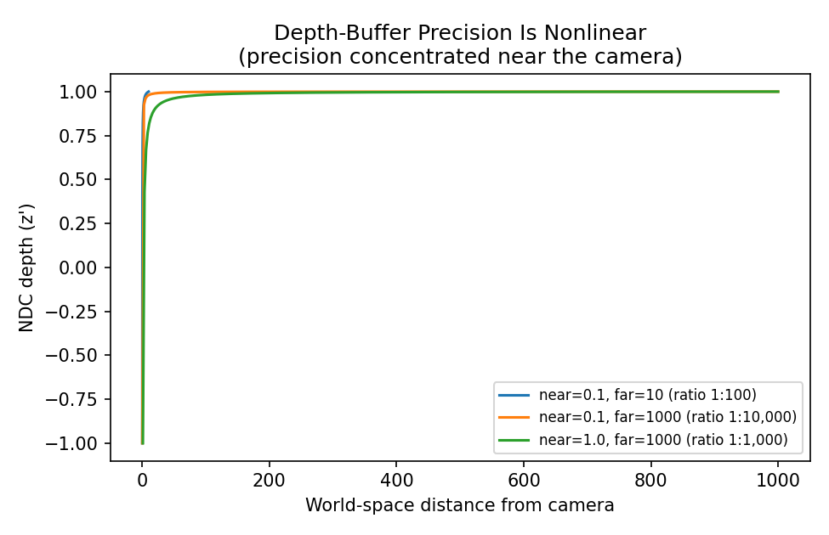
Figure 7. NDC depth vs. world distance for three near/far configurations.
Near / Far | Ratio | World-space fraction consuming 90% of NDC range
0.1 / 1000 | 1 : 10,000 | 0.09%
1.0 / 1000 | 1 : 1,000 | 0.89%
0.1 / 10 | 1 : 100 | 8.26%
For a near:far ratio of 1:10,000, the closest 0.09% of the world-space frustum depth already consumes 90% of the entire depth-buffer's numeric range — the remaining ~99.9% of world-space depth is squeezed into the last 10% of representable values. This is a genuine hardware/system constraint, not a bug: a real GPU's depth buffer has finite bits (commonly 24), and this analysis shows precision is spent overwhelmingly near the camera regardless of implementation. The practical implication for this system (and for any production renderer) is to pick the tightest near/far bounds the scene actually requires, since it is the ratio — not the far distance in isolation — that determines how usable the remaining depth precision is at range.

3.4 float32 (GPU-Grade) vs. float64 Pipeline Divergence
The full Milestone 1 character was pushed through the identical Model→View→Projection→Screen pipeline twice: once at float64 (this system's default), once with every matrix and vertex cast to float32 (the precision virtually all real GPU hardware uses natively).
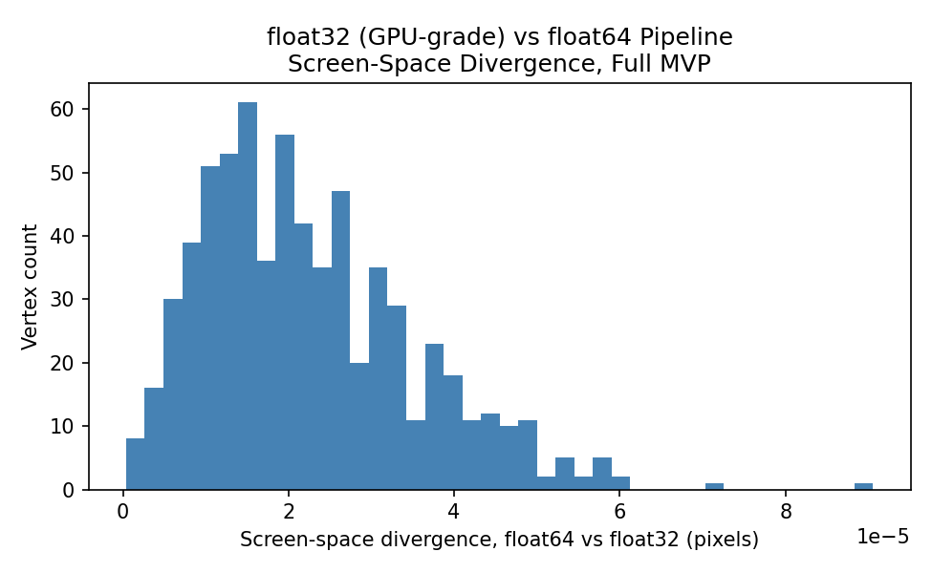
Figure 8. Per-vertex screen-space divergence, float64 vs float32 pipelines.
Maximum divergence across every mesh vertex was ≈ 9.06 × 10⁻⁵ pixels; mean divergence ≈ 2.24 × 10⁻⁵ pixels — both far below any visually perceptible threshold. This confirms that GPU-standard float32 is numerically adequate at this character's scale and camera distance. It would not remain adequate at much larger world scales (e.g. open-world coordinates in the tens of thousands of units), which is precisely why large-scale engines render camera-relative or use a floating origin: keeping vertex coordinates small and close to the camera before the float32 pipeline touches them, rather than trusting float32 to hold precision across a huge absolute coordinate range.

3.5 System / Hardware Constraint Summary
- Precision budget: GPUs operate natively in float32 (sometimes fp16 on mobile); this system's float64 Python implementation is a convenience, not a requirement — Section 3.4 shows the pipeline degrades gracefully to GPU-grade precision at this scale.
- Depth-buffer bit budget: real hardware depth buffers are commonly 24-bit fixed-point or float; Section 3.3 shows precision allocation across that budget is controlled by the near:far ratio, an actual scene-authoring decision, not just a rendering detail.
- Per-vertex cost: the transformation pipeline is O(vertices × 4×4 matrix multiplies) per frame; batching all vertices into a single matrix-multiply call (as implemented in project_points) rather than looping in Python is what makes this remotely tractable at interactive rates, and mirrors why real pipelines batch vertices into GPU buffers rather than transforming them one at a time.
- Rigid-transform inversion: view-matrix inversion (Section 1.1) deliberately avoids a general 4×4 inverse in favor of the closed-form rigid-transform inverse (transpose + negated translation) — cheaper and immune to the conditioning problems a general matrix inverse can have.

4. Deliverables
File | Contents
camera.py | View matrix (look-at), perspective & orthographic projection, full MVP pipeline, near-plane clipping
build_milestone2.py | Renders perspective/orthographic/three-view/turntable outputs using camera.py + Milestone 1's Skeleton/SkinnedMesh
numerical_stability.py | All four numerical experiments in Section 3, producing plots + numerical_stability_results.json
m2_perspective_view.png / m2_orthographic_view.png | Figures 1–2
m2_three_views.png | Figure 3
m2_turntable.gif | Full 36-frame camera-orbit animation (Figures 4a–4b are stills from it)
ns_quat_drift.png / ns_fk_chain_error.png / ns_depth_precision.png / ns_float32_vs_64.png | Figures 5–8
numerical_stability_results.json | Every quantitative figure cited in Section 3
M2_Report.docx | This report

